PYTHON PROJECT

Cafe Management System

Name-ASHISH AGRAWAL
Er.no-151257
Batch-B2
Email-ashishbyn@gmail.com
PROJECT – CAFE MANAGEMENT SYSTEM

Description-
- First main page it consists of 3 Buttons:
a:Enter
b:About us
c:Exit
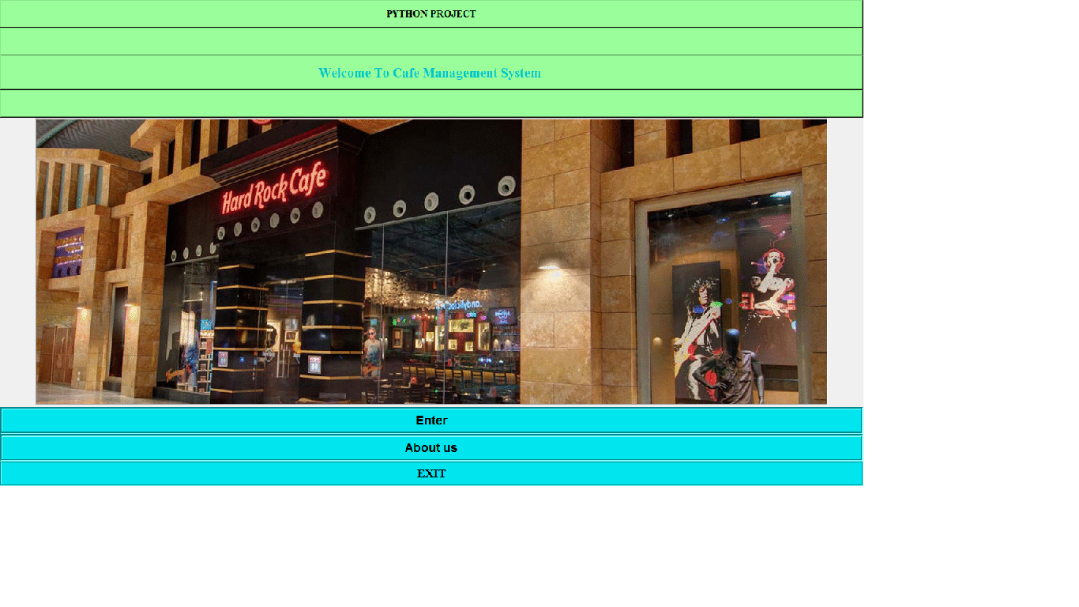

Now when we click on About us Button:
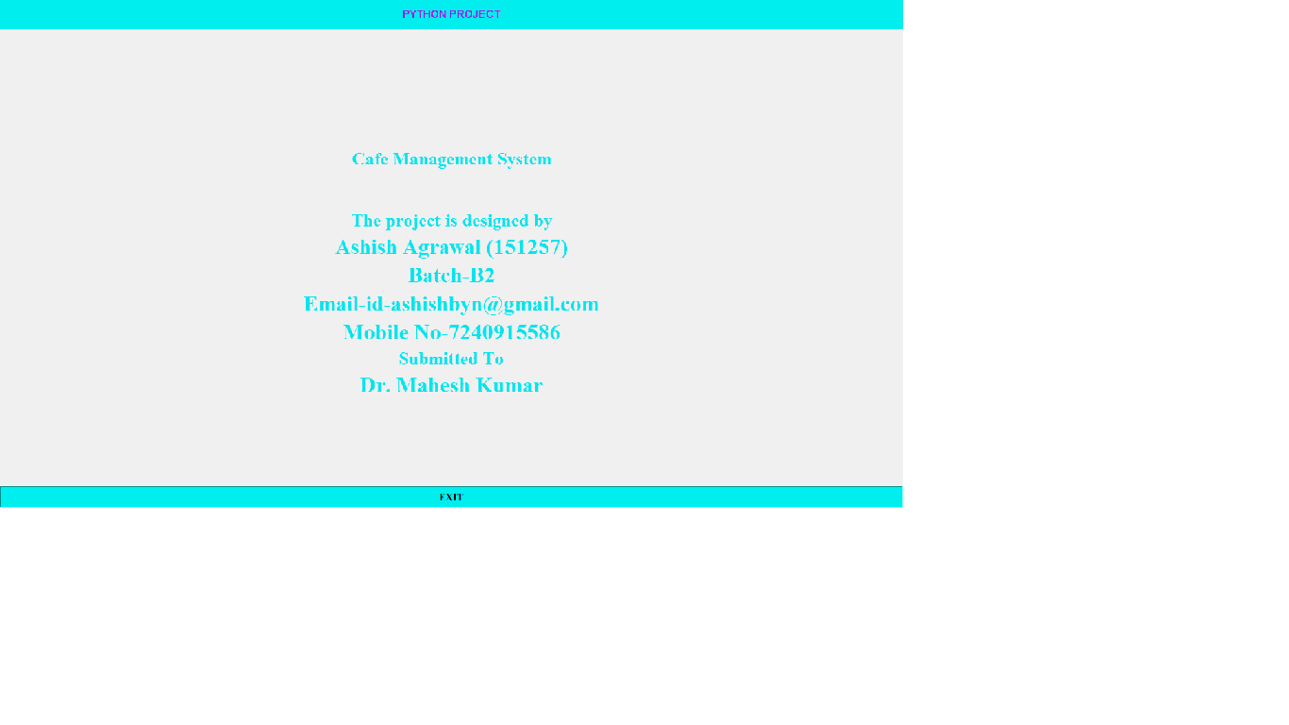

Now when we click on EXIT Button:
Then one window display
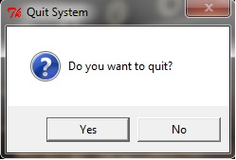

Now the main part the Enter Button:

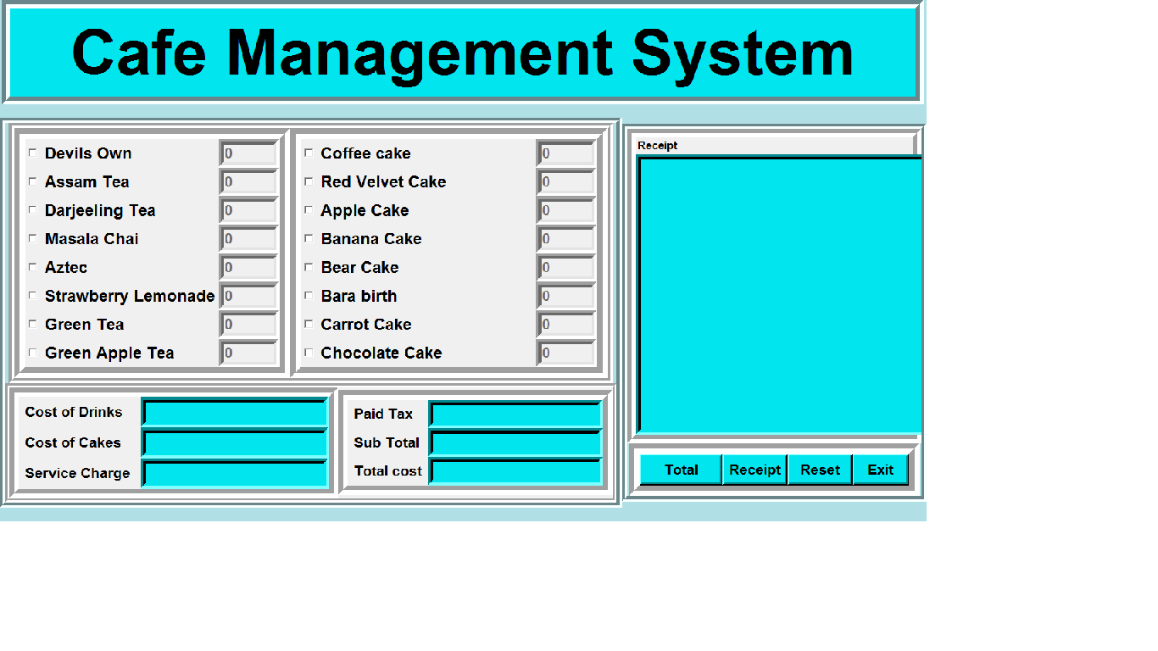

in this GUI i used :
a.Lavel
b.Entry
c.checkbutton
d.frame
e.Buttons

Lavels in this GUI is used for assigning my dishes ex-different types of drinks and cakes and heading of my page.

Checkbuttons is used for my dishes name and there is a entry box or we can say textbox which is used to enter the quantity.

Currently it is disabled to enabled it you have to click on the dish name which is in the form of checkbutton.

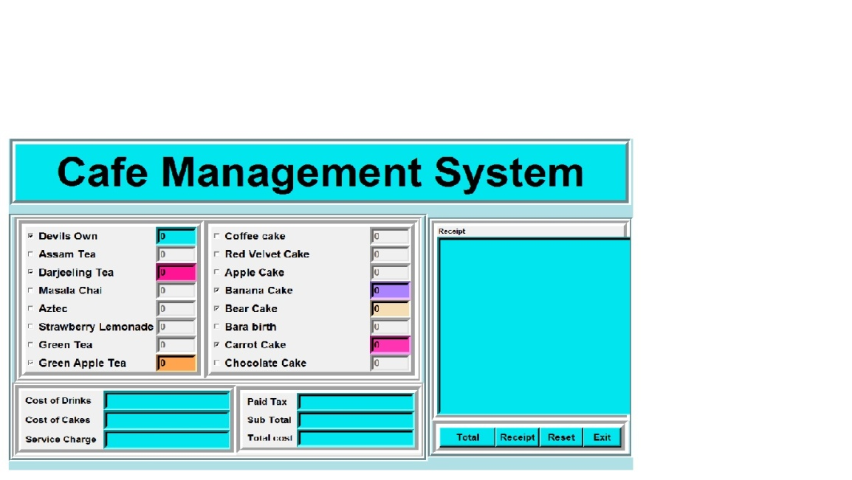

6 entry box for
1.cost of drinks
2.cost of cakes
3.paid tax
4.service charge
5.sub total
6.total cost

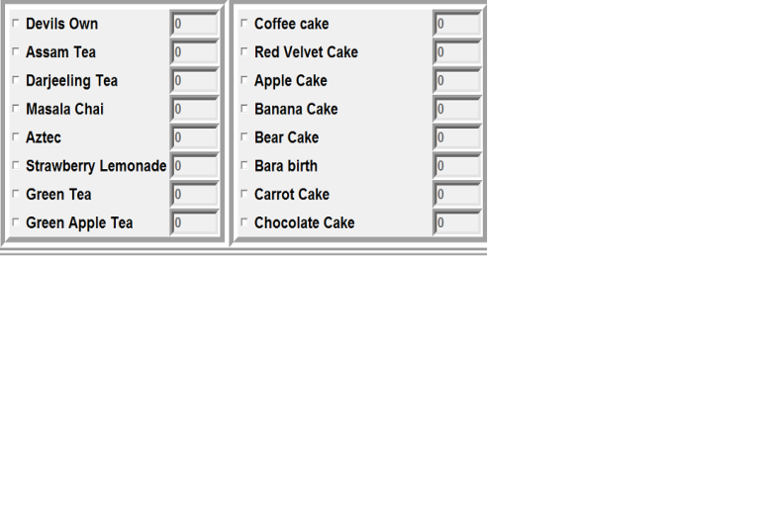
and 2 frames for my dishes

in root window has 4 buttons:

1.Total
2.Receipt
3.Reset
4.Exit

1.Total
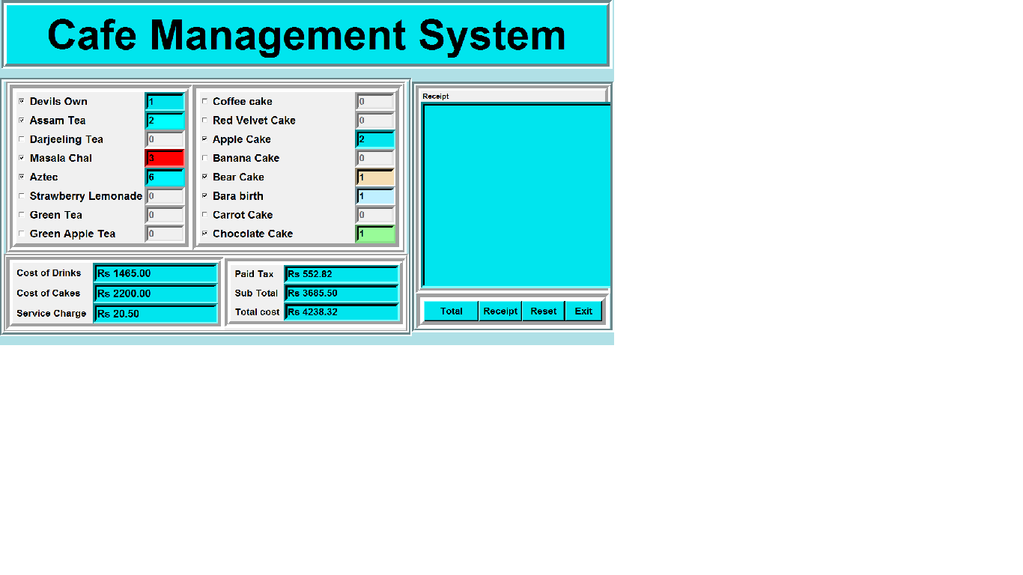

2.Receipt
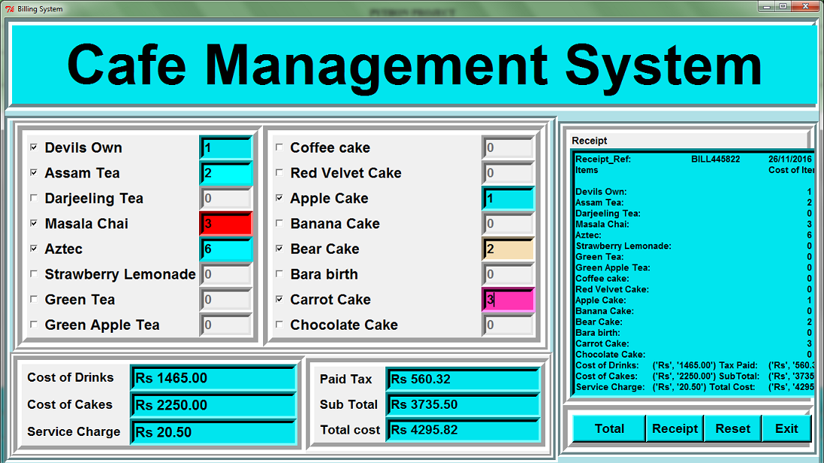

3.Reset

4.Exit

Then you want to click yes
then project will be close.

